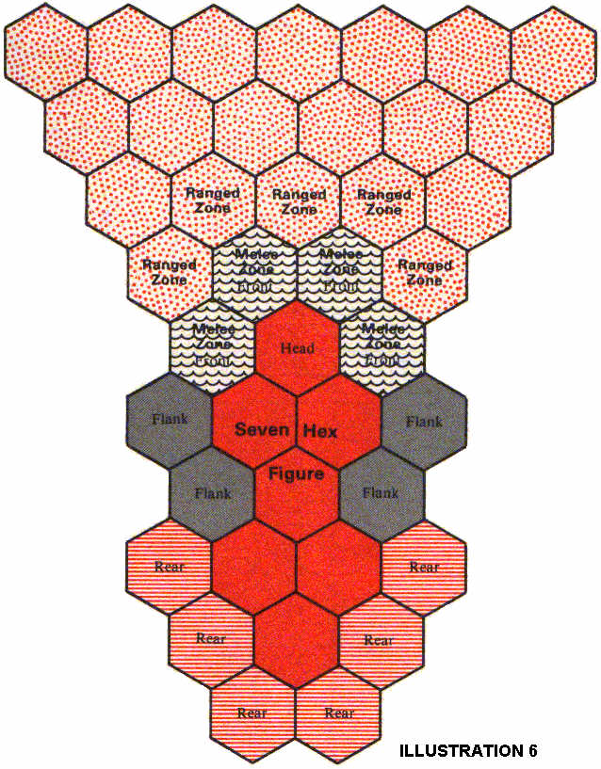
COMBAT EXAMPLE
The following is an example of the way a typical combat will be resolved, emphasizing order of resolution rather than detailing the actual die rolls and success chances.
A party of player characters is travelling by foot along a path deep within a forest. They are alert but not combat-ready; they are tired from having traveled long and hard all day. The party consists of Ariella, a Celestial Mage, Eaglewing, an Elven Ranger; and, Delion, an Elven Illusion-ist. The GM has generated an ambush for the party as they round the next bend in the path, and assigns a readiness factor (see 80.2) of 3 to their chance to detect the ambush. Eaglewing is leading the party, so his Perception of 10 is used for the check, but he also receives a bonus of 15% due to his Ranger Rank. Eaglewing does detect the ambush, and the Hobgoblin, Orc, and Goblin lying in wait will get no surprise this day. The GM determines they will attempt the attack anyway, and combat begins. The GM draws out the surroundings, places the characters' minia-tures on the Display, and then places the monsters' figures. He determines the characters' Fatigue loss (due to their long march), and adjudicates the monster's Fatigue status. He allows the characters to prepare a weapon, if they wish, because of the alertness of Eaglewing.
CHARACTER GENERATION & COMBAT, PAGE 23

First Pulse. The Hobgoblin (Perception of 13) is the Leader of the monsters. Eaglewing is the party's Leader. The GM rolls Initiative for the monsters, and Eaglewing's player rolls for the party. The Hobgoblin wins and decides that the monsters will act first. The Hobgoblin tries to goad his mount (a horse) to Charge Eaglewing. The GM rolls the Hobgoblin's Horsemanship check; it is successful and the charge occurs. The Hobgoblin is not close enough to Eagle-wing at the end of the Charge to Melee him with his Scimitar. The Orc throws his spear at Ariella and misses. The Goblin fires his Cross-bow at Delion and hits him, profiting from the +20 bonus for attacking Delion from a Rear hex. Delion takes 9 points of Fatigue damage (4 of which is absorbed by his Leather Armor) and becomes Stunned. He is unable to hold on to his Rapier, which falls to the ground. Now the party may act. Eaglewing, having prepared his Tulwar upon becoming aware of the ambush, sets himself to receive the Hobgoblin's Charge by taking an Evade Action (he has achieved Rank 5 with the Tulwar, so he thinks he has a
good chance to Parry). Ariella prepares a spell, and begins to pronounce the magical incanta-tions. She may not move. Delion acts last as he is Stunned. He may only attempt to recover from Stun; he tries and fails.

Second Pulse. The Initiative roll is won again by the Hobgoblin. He Charges Eaglewing and attacks. His Strike Check is 37 above his Modified Strike Chance, so Eaglewing may Parry. He rolls an 8, plus 6 for his Rank, minus 3 for the Hobgoblin's Rank, yields a result of 11, a Disarm and Riposte. Eaglewing hits the Hobgoblin with his Riposte, doing damage affecting Endurance for 12 points. The Hobgoblin is Stunned, and the GM checks to see if he falls from his horse. He does, and falls at Eaglewing's feet. The Orc prepares his Scimitar and moves slightly towards Delion. The Goblin begins to reload his crossbow. Eaglewing attacks the prone Hobgoblin (the Riposte does not count as an Action), receiving a +15 for the Hobgoblin being Stunned and a + 20 for his being prone (the Hobgoblin's Defense is not subtracted because he is Stunned). Eaglewing strikes for a Grievous Injury this Pulse and kills the unfortunate Hobgoblin. Ariella tries to cast her spell of Starfire (knowing full well she is receiving a -20 penalty because it is still day-time) and does, doing 13 points of damage to the Goblin, who becomes Stunned and drops his bow. Delion tries again to recover from Stun, and succeeds.
Third Pulse. This time Eaglewing wins the Initiative Roll (performed against the Orc since the Hobgoblin is dead). Since no one is engaged yet (the Hobgoblin does not engage Eaglewing because he is dead), he chooses to have the party act first. He prepares his Main-Gauche, and moves slightly towards the Orc. Ariella begins to prepare another Starfire. Delion picks up his Rapier and changes facing to receive the Orc's attack. The Orc moves up to Delion and Melee attacks him, missing. The Goblin recovers from being Stunned.
Fourth Pulse. Initiative is rolled between Eaglewing and the Goblin, since the Orc is engaged with Delion. Eaglewing wins it. However, since the Orc and Delion are engaged, their combat is resolved before anything else. The Orc's Initiative Value is 27, Delion's is 25, so the Orc may act first. He attacks Delion, inflicting enough Fatigue damage with his successful attack that Delion is out of Fatigue (remember, the party was tired to begin with). Delion, seeing the way the battle is going, Withdraws defensively. Eaglewing chooses to have the party act first and allows Ariella to try her spell before he himself takes any action. Ariella, however, is not so lucky this time and her spell backfires, reducing her Fatigue to 0 and Stunning her. Eaglewing (frustrated at the Adept's fumblings) moves up to the Orc, at-tacking him from behind. He receives a + 30 for attacking from a Rear hex but a -15 for Charging with a non Pole weapon. His attack is successful, doing enough Fatigue damage to Stun the Orc. Delion cannot act now because he has already performed an Action earlier in the Pulse. The Goblin runs away.
Fifth Pulse. Eaglewing asks the Orc to sur-render and the Orc accepts, thus ending the need for the Tactical Stage.

Weapons are normally wielded one-handed, and the exceptions are noted with a (2) after the name of the weapon. Some may be used either one or two-handed, and these are noted with a (1-2). When weapons of this type are wielded two-handed, increase their Damage Modifier by 1. "-" indicates that a weapon has no Class for purposes of Grievous Injuries; when a possible Grievous Injury is rolled, only damage affecting Endurance results. "V" indicates that the characteristic is variable. *The damage done by a blowgun dart depends upon the substance which coats the tip (poison, for instance; see 50.8 and 20.3).
A. When attacking a foe whose modified Agility is between 12 and 9 (inclusive) the Dagger may be used to attack twice in one Pulse without penalty; if the modified Agility is 8 or less, the Dagger may attack 3 times in a Pulse.
B. A Torch is not actually a weapon, but may be used as such in emergencies. Also, brandishing a burning Torch in the face of an animal may cause it to flee. Any animal whose WP is 10 or less may be scared off if it fails a roll of 4 times its WP or less. A successful roll indicates the animal is not impressed. No Rank may ever be achieved with a Torch.
C. The Sap may only be used to knock out targets wearing only Leather, Cloth, or no armor. Used by an Assassin, any hit knocks out the target; for anyone else, any hit Stuns and 4 or more points of effective damage knocks out the target (exception to 16.5).
D. A Javelin functions as a Thrown Weapon unless it is launched by a Spear Thrower, in which case the Spear Thrower's characteristics are used and it functions as a Missile Weapon.
E. A Pike may be used to Melee attack any figure within two hexes; its Melee Zone extends into what would normally be the first hexes of that figure's Ranged Zone.
F. A Lance may be used only by a mounted figure.
G. All Missile Weapons must be loaded before firing; this action is in addition to Preparing the weapon itself. A Pass action must be taken in order to load the Sling, any draw bow, the Spear Thrower, and the Blowgun. Two consecutive Pass actions must be taken to load a Crossbow (three if using a Cranequin).
H. Up to three darts may be thrown at one, two, or three targets in one Pulse with no penalty.

DRAGONQUEST SECOND EDITION, PAGE 24

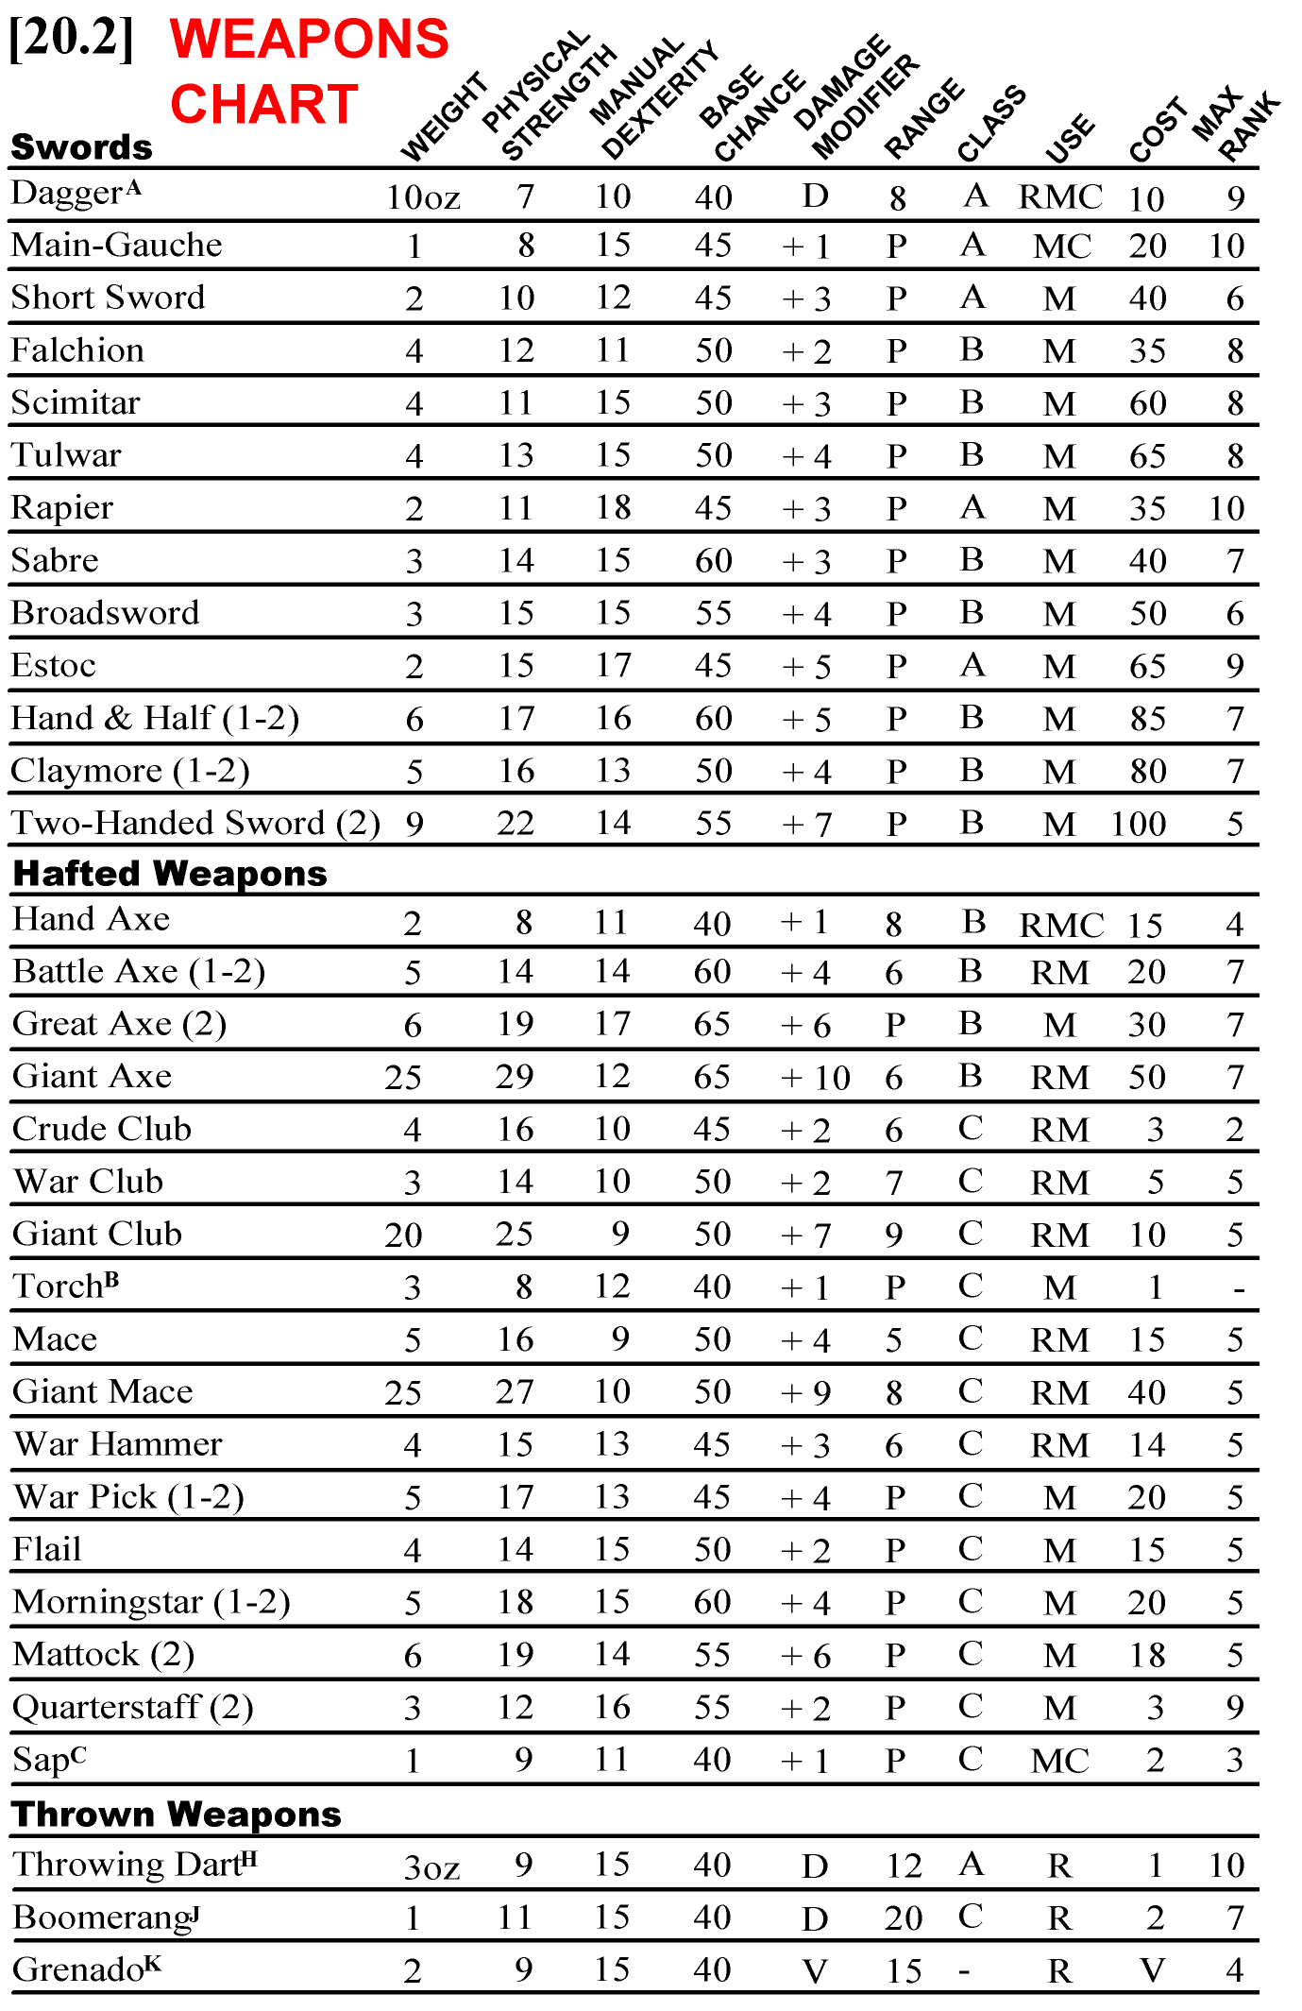
The following weapons also function as Thrown Weapons: Dagger, Hand Axe, Battle Axe, Giant Axe, Crude Club, War Club, Giant Club, Mace, War Hammer, Javelin, Spear, Giant Spear, Net, Bola, and Rock.

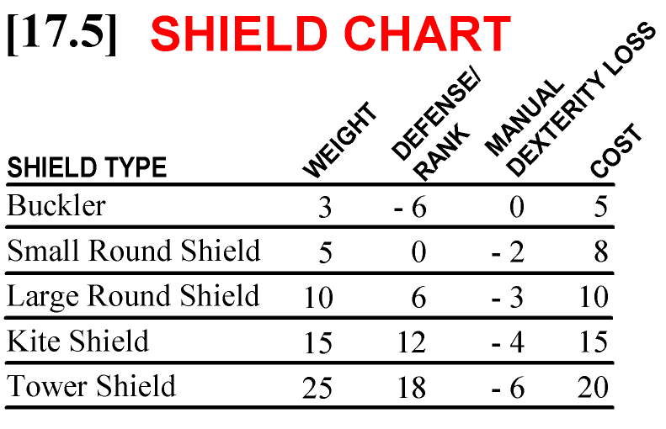

Weight: The weight of the shield in pounds.

Defense Rank: The percentage by which the figure's defense is increased per Rank while that shield is prepared.

Manual Dexterity Loss: The number of points the figure's Manual Dexterity is reduced by, for all purposes while that shield is prepared.

Cost: The cost in silver pennies for a shield of average workmanship.

*The Main Gauche does not subtract its defense from any Fire attack, and cannot make a Shield Rush attack (see 16.5). The Main Gauche functions both as a weapon and a shield, and only one Experience Point expenditure is used to rise in Rank in both, that of the weapon listed in 87.8. When a shield is not prepared, it is considered slung on the back of the figure carrying it. All shields except the Tower Shield and the Main Gauche are constructed of wood and hides and do not affect the flow of mana in regard to adepts.

CHARACTER GENERATION AND COMBAT, PAGE 25
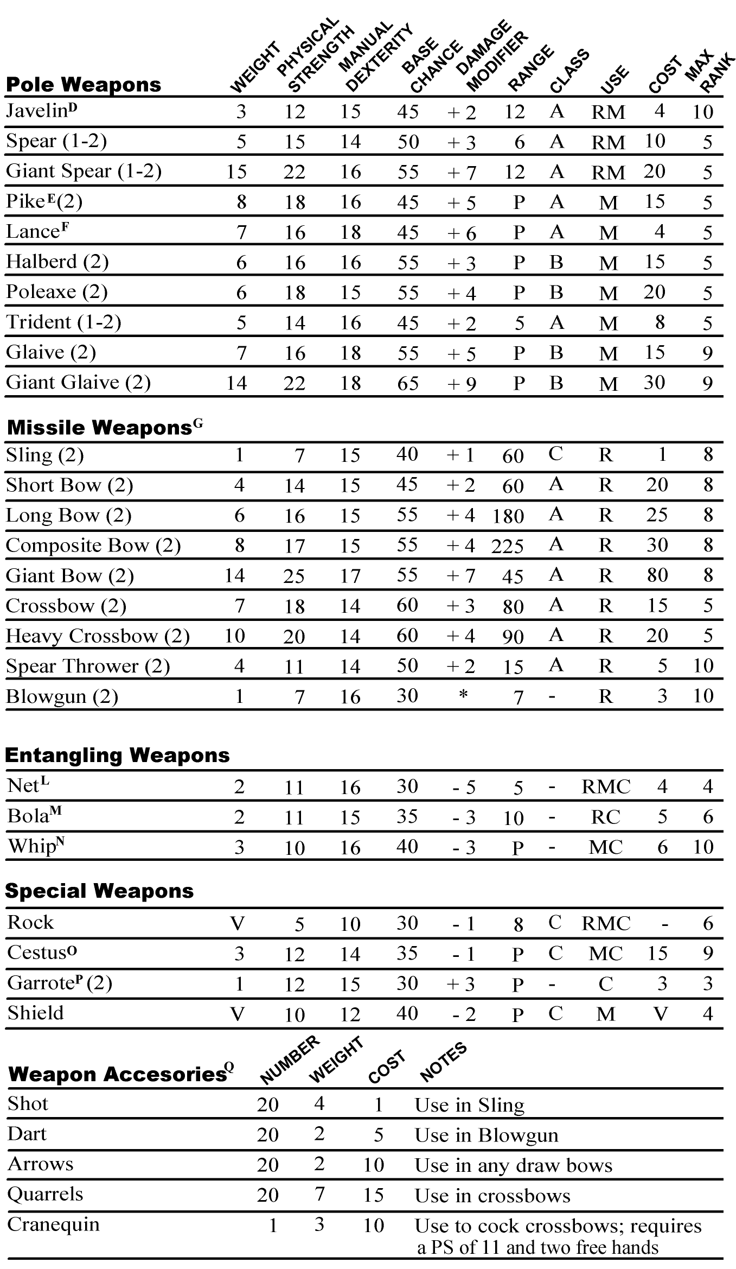

J. A Boomerang returns to the thrower if it did not hit anything during its flight.
K. A Grenade is filled with any substance (manufactured by an Alchemist) designed to burst into flames on impact. These substances include Greek Fire, methane, and anything else the GM will allow. It bursts on landing (if need not be thrown at a particular figure), and its effects are determined by the substance contained within. If a "miss" is rolled for the Strike Check, the GM should randomly determine whether the Grenade landed short, long, left, or right of the target (or any combination thereof).
L. The Net may be used to Entangle in either Melee or Ranged combat. In Close combat, it functions as a Garrote, using a Garrote's characteristics.
M. The Bola may be used to Entangle only in Ranged combat. In Close combat, it functions as a Garrote.
N. The Whip may be used to Entangle and do damage in the same Pulse to the same target in Melee combat. In Close combat, it functions as a Garrote. Once the target is Entangled, the attacker may choose to leave him Entangled (thus letting go of the Whip), or disentangle the target himself, and retain possession of the weapon.
O. Cesti are worn on the hands and need not be prepared in order to be used.
P. The Garrote is used to strangle the target and may only be used against man-sized or smaller victims. When used by a trained Assassin, once a successful hit has been scored, it will continue to do damage every Pulse from then on until the victim is dead or the Assassin has taken effective damage from either the victim or an outside source. If the victim's PS is greater than the Assassin's, the GM may permit him to at- tempt to break the hold, similar to the attempt to Restrain (see 16.5). If the attempt is successful, the hold is broken and the Assassin will have to make another successful Strike Check to continue the strangulation. Some types of plate armor may, at the GM's discretion, prevent the successful use of this weapon due to protection around the neck area. A non-Assassin has to roll a Strike Check every Pulse to see if any damage can be done.
Q. All Shot, Darts, Arrows, and Quarrels come in appropriate pouches or quivers of 20, and the weight and cost of the pouch or quiver is included in the information given for the accessory.

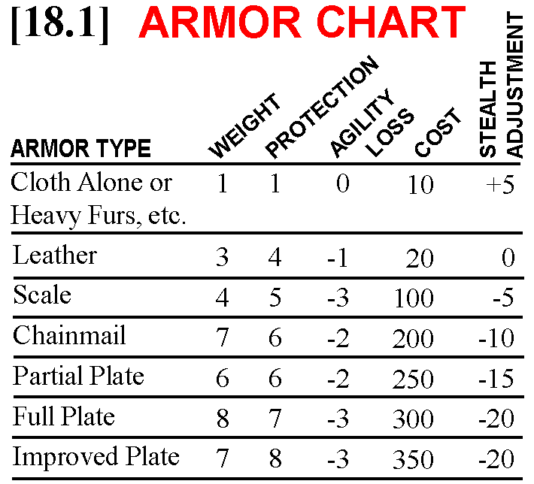

Weight: The number by which a figure's size is multiplied to find the weight of the armor in pounds. Size numbers for the character races are: Halfling (3); Dwarf (4); Elf (5); Orc (5); Human (6); Giant (15). For female figures, 0.5 should be Subtracted from the multiples.
Protection: The number of Damage has his Points the armor absorbs.
Agility Loss: The number of points the figure's Agility is reduced for all purposes when that armor is worn. Does not include possible additional Agility loss for the weight of the armor; see 82.9

Cost: The cost in Silver Pennies for the armor. Cost assumes average workmanship and man-sized armor; larger or smaller armor should cost proportionally more or less.
Stealth Adjustment: The amount by which a figure wearing that type of armor has his Stealth percentage adjusted.
Note: Cloth armor is worn underneath all other armors and its protection weight are factored into those armors.

DRAGONQUEST SECOND EDITION, PAGE 26
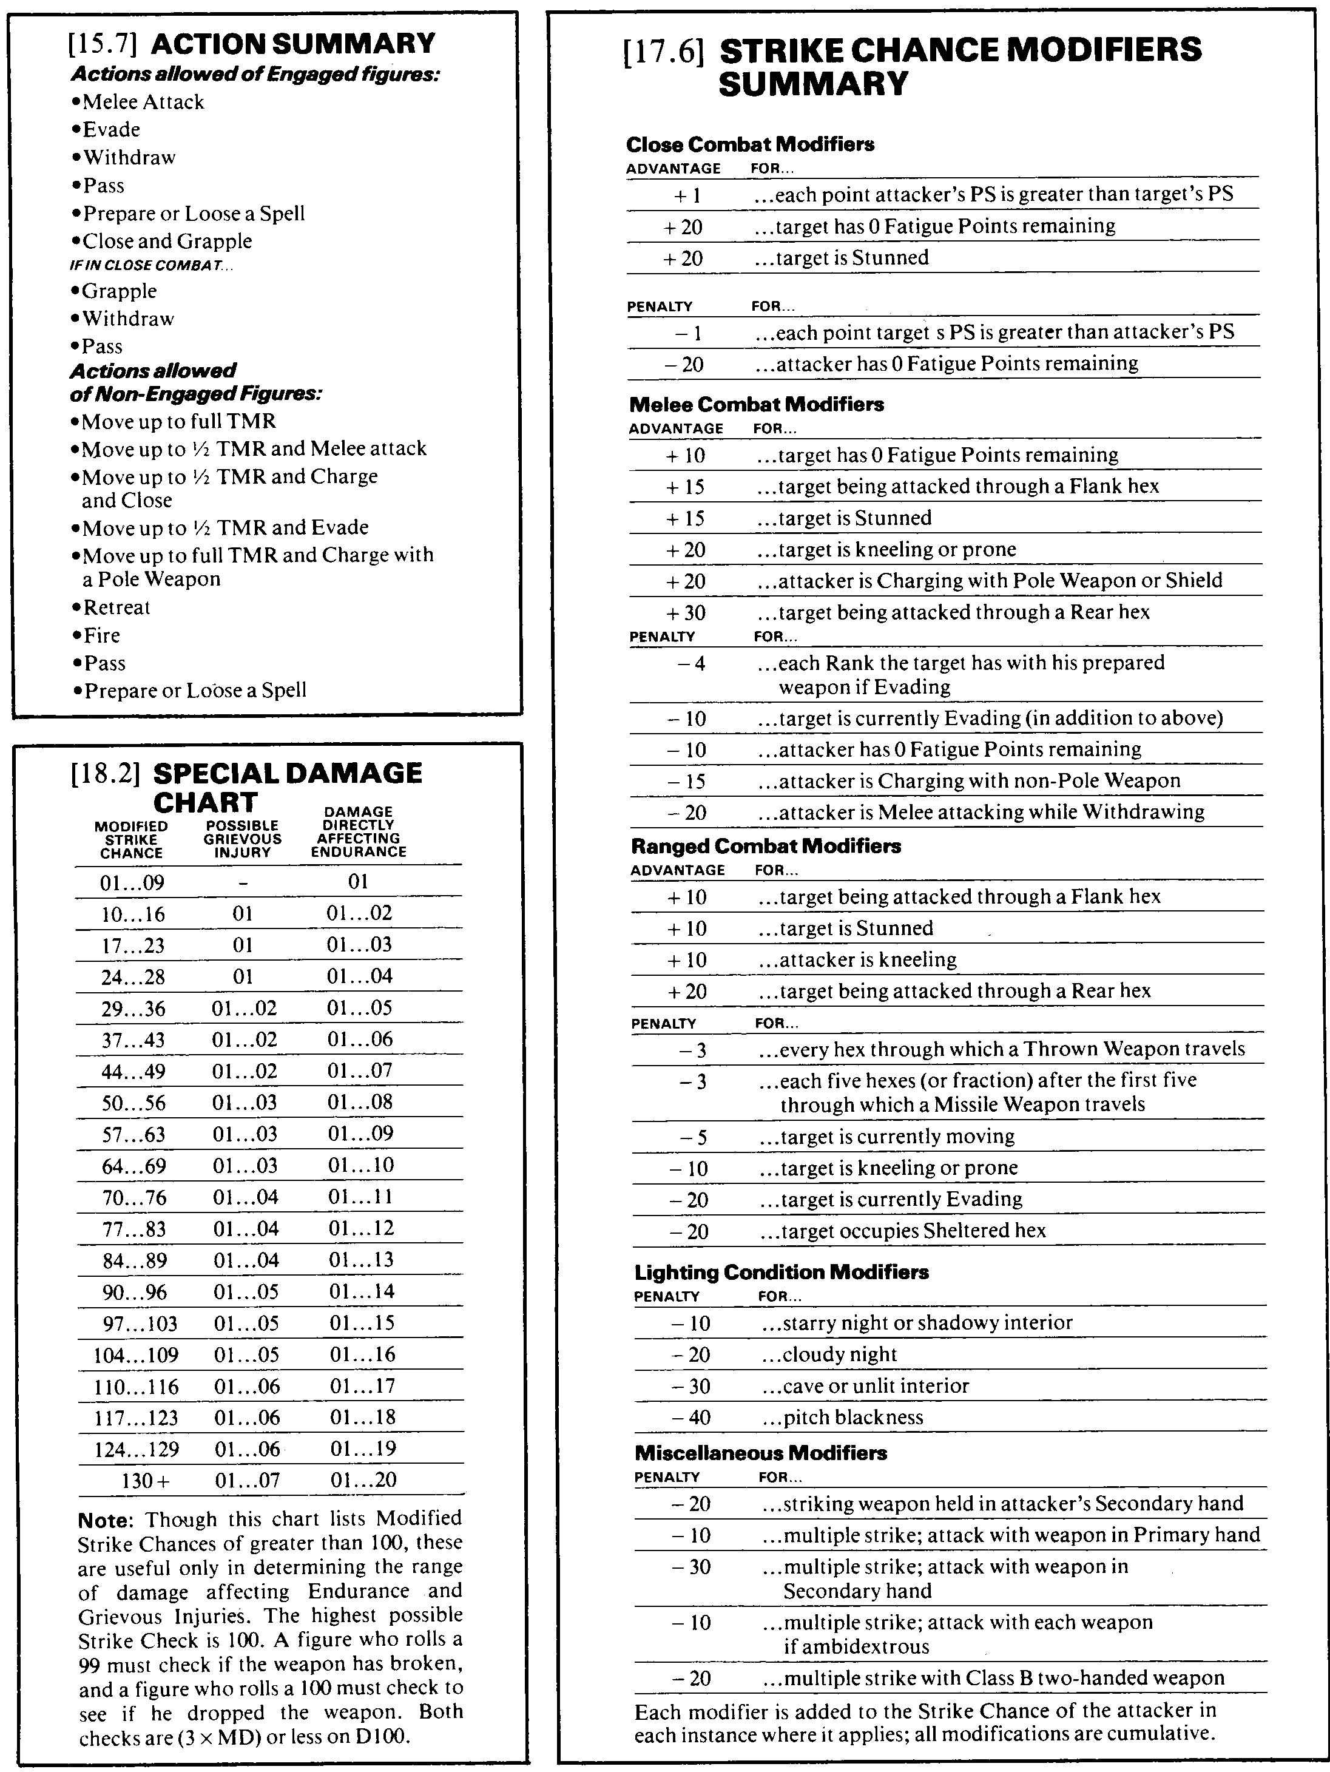

[18.3] GRIEVOUS
INJURY TABLE
Class A weapons do Grievous Injuries on rolls of 01 through 20. Class B weapons do Grievous Injuries on rolls of 21 through 80. Class C weapons do Grievous Injuries on rolls of 70 through 100.
D100 Result
01-05 Congratulations! It's a bleeder in your primary arm! Take 1 Damage Point from En- durance immediately and 1 per Pulse thereafter until the flow is staunched by a Healer of Rank 0 or above or you die.
06-07 Oh no! Your opponent's weapon has entered your secondary arm's elbow joint and the tip has broken off. Take 2 Damage Points immediately from Endurance and that arm is useless until the sliver has been removed by a Healer of Rank 3 or above. Also, increase the chance of infection by 30.
08 A vicious puncture wound in your groin! Take 3 Damage Points immediately from En- durance and reduce your TMR by 2 until fully recovered, which will take two months. In addition, add 30 to your chance of being infected (assuming you live long enough for such things to matter).
09-10 You have been stabbed in your secon-dary arm. Drop whatever you were holding in it and take 2 Damage Points immediately from Endurance. It will take a full week for the arm to be of any use to you whatsoever.
11 Your aorta is severed and you are quite dead. Rest assured your companions will do their best to console your widow(er).
12 A stomach puncture. Nasty. You suffer 3 Damage Points immediately from Endurance and lose 2 from your TMR until fully recovered, which will take two months. Also, you are automatically Stunned for the next Pulse (if you aren't already), after which you will recover. Add 20 to the chance to be infected.
13 Your opponent's weapon has entered your eye; roll D10. On a roll of 1, the weapon has entered your brain and you are dead. On a roll of 2-5, your left eye is blinded; on a roll of 6-10, your right eye is blinded. If you are lucky enough to be blinded instead of killed, you have suffered 2 Damage Points to Endurance. In ad-dition, a figure who is blind in one eye suffers the following subtractions: -2 from Physical Beauty; -4 from Perception; -1 from Manual Dexterity. A figure blinded in one eye reduces his Base Chance with any Missile or Thrown Weapon by 30.
14-18 Tsk. Tsk. A wound of the solid viscera. Usually fatal. Take 3 Damage Points to En- durance immediately and 1 per Pulse thereafter until the bleeding is stopped by a Healer of Rank 2 or above or you die. Add 30 to the chance of infection.
19-20 Take a stab in the leg (your choice as to which one) resulting in a deep puncture of the thigh muscle. Suffer 1 Damage Point to Endurance immediately and reduce your TMR by 1 until you heal, which will take 4 weeks.
21-25 A chest wound. Take 2 Damage Points to Endurance immediately and reduce your TMR
CHARACTER GENERATION & COMBAT, PAGE 27

by 1 until recovered (about 2 months). Look on the bright side, though. Your attacker's weapon is caught in your rib cage and has been wrenched from his grasp.
26-27 Bad luck! Your secondary hand has been severed at the wrist. Take 2 Damage Points to Endurance immediately and subtract 1 point per Pulse from Fatigue thereafter (Endurance when Fatigue is exhausted) until you are dead or the bleeding is staunched by a Healer of Rank 0 or above. If you live, reduce your Manual Dexterity by 2.
28-30 Worse luck! Your primary hand has been severed. See result 26-27 for effects.
31-34 A minor wound. Your face is slashed open, ruining your boyish good looks and caus-ing blood to spurt into your eyes. Reduce your Physical Beauty by 4 permanently.
35 Your secondary arm is sliced off at the shoulder. Take 5 Damage Points immediately from Endurance and 1 per Pulse thereafter from Fatigue (Endurance when Fatigue is exhausted) until you are dead or the bleeding is staunched by a Healer or Rank 1 or above. Reduce your Manual Dexterity by 2 and your Agility by 1.
36 The same as 35, except it's your good primary arm that has been lopped off.
37-40 You have been eviscerated! Take 4 Damage Points immediately from Endurance and 1 point per Pulse from Fatigue thereafter (Endurance when Fatigue is exhausted) until you are unconscious. Increase your chance of infection by 40.
41-42 A glancing blow lays open your scalp and severs one ear (your choice as to which one). Take 2 Damage Points immediately from Endurance. Reduce your Perception by 2.
43 A savage slash rips open your cheek and jaw. Take an automatic Pass action next Pulse due to the shock of the blow. Your Physical Beauty is increased by 1, since your disfigure-ment will bring out the maternal/paternal in-stincts in the opposite gender.
44-50 A slash along one arm, and it's a bleeder! Take 2 Damage Points immediately from En- durance and lose 1 point from Fatigue (En- durance when Fatigue is exhausted) each Pulse until the bleeding is stopped by a Healer of Rank 1 or above or you die.
51-52 Hamstrung! Roll D10. On a roll of 1-4, it is your left leg. On a roll of 5-10, it is your right. Take 4 Damage Points immediately from Endurance and fall prone. You may not stand unassisted until the wound is healed (which should take three months). Reduce your Agility by 3 permanently.
53-60 Your primary arm is crippled by a wick-ed slash! Take 2 Damage Points immediately to Endurance and drop anything you have in your primary hand. The arm is unusable until healed, which should take 2 months.
61-67 Your secondary arm is crippled; see 53-60 for details.
68-69 A nasty slash in the region of the shoulder and neck. Roll D10. On a roll of 1-3, your head is severed and your corpse tumbles to the ground. On a roll of 4-6, your secondary collar bone is crushed; on a roll of 7-10, your

primary collar bone is crushed. If your collar bone is crushed, the results are identical to 53-60, except you suffer 4 Damage Points to Endurance.
70-74 A crushing blow smashes your helmet and causes a concussion. Take 3 Damage Points from Endurance and suffer a reduction of 4 in both Manual Dexterity and Agility lasting for 3 days.
75-80 A massive chest wound accompanied by broken ribs and crushed tissues. Very ugly, this. Take 5 Damage Points immediately from En- durance. Reduce your Manual Dexterity and Agility by 3 each until this wound heals (should take about 4 months). Increase your chance of infection by 10.
81-84 A crushing blow smashes tissue and pro-duces internal injuries. You suffer 2 Damage Points immediately to Endurance and 1 per Pulse thereafter to Fatigue (Endurance when Fatigue is exhausted) until unconscious or you receive the attention of a Healer of Rank 2 or above.
85-87 A jarring blow to your primary shoulder inflicts 2 Damage Points immediately to En- durance. Roll D10; the result is the number of Pulses the arm is useless. You immediately drop anything held in that hand.
88-89 Similar to 85-87 except it is your secondary shoulder.
90-92 Your right hip is smashed horribly. Take 5 Damage Points immediately to Endurance and fall prone. You will be unable to walk until the damage has healed (takes about 6 months). Good fun. When healed, you will still have a limp which will reduce your TMR by 1 and your Agility by 2.
93-94 The same as 90-92 except it is your left hip that is smashed.
95-97 Your opponent's weapon has come crashing down on your head and fractured your skull. You fall prone and are unconscious, and take 8 Damage Points to Endurance. If you sur-vive, you lose 2 from Agility, 2 from Manual Dexterity, and 2 from Perception. It will take a year in bed to recover.
98-100 Crushing blow to your pelvis breaks bone and tears tissue. Take 7 Damage Points immediately to Endurance and fall prone. Try to roll under your Willpower on D100 to avoid falling unconscious. If you survive, you will be unable to move for D10 months.
NOTES: The suggested recovery times are a guide- line for the GM's to use in determining how long characters should be kept out of action. The actions of a competent Healer may alter these times in some instances. These Grievous Injuries are designed for combat between human-sized opponents; any injuries sustained involving larger monsters should be applied judiciously by the GM, taking into account size and mass differences, etc. Simply stated, a halfling would be hard put to drive his dagger into the eye of an elephant, and in situations such as these, the GM may have to disallow the Grievous Injury or change its effects. Any damage which results from a Grie-vous Injury is in addition to the Endurance damage already determined.
TACTICAL DISPLAY
DRAGONQUEST SECOND EDITION, PAGE 28
Scale: 1 hex = 5 fee

